Protocol for Use of Skin Markers in Mammography
Facility Name
PROTOCOL: | Standardized consistent use of radiographically distinct mammographic skin markers that aligns with American College of Radiology (ACR) / Society of Breast Imaging (SBI) recommendations and the Lead Interpreting Physician’s policy on skin marking.
PURPOSE: | The purpose of these guidelines is to assure proper use of skin markers to facilitate radiologist interpretation, avoid confusion when reviewing against prior exams with skin marker comparison, aid in interpretation by other radiologists from outside facilities, and with future interpretations.
SCOPE: | This skin marking protocol applies to all breast imaging staff performing mammograms at this breast imaging center.  Marker location should also be documented on the breast diagram.
IMAGING EQUIPMENT: | ☐ DBT (Digital Breast Tomosynthesis)  ☐ Digital  ☐ Analog
5-SHAPE COMMUNICATION SYSTEM: | 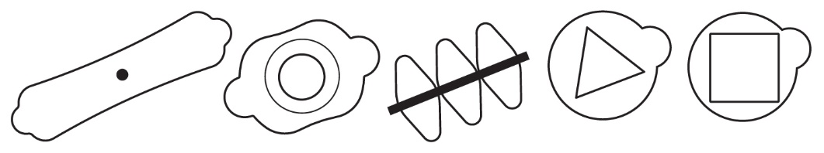  The checked boxes below indicate what areas of the breast will be marked:  ☐ ☐ ☐ ☐ ☐  Nipple Mole Surgical Scar Palpable Mass Area of Concern or Pain
Triangle marker: | Triangle Used for Palpable Finding:  ☐ Place triangle over palpable lump and leave in place for both views.  Leave on if patient is going to Ultrasound.  ☐ Place triangle over mass for initial view. Move marker for the  orthogonal view so that it is again over the mass in that projection  and not imaged in tangent. Leave on patient if going to Ultrasound.
Circle marker:  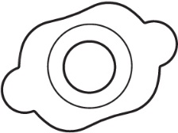 | Circle Used for Skin Mole:  ☐ Placed over all raised skin moles during screening mammography.  ☐ Maximum number of circle markers to be used when there are multiple  raised skin moles: Click or tap here to enter text.  ☐ When requested by radiologist for diagnostic exam.
Linear marker:  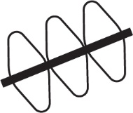 | Line Used for Scars:  ☐ Place over length of visible scar(s) during screening mammography.  ☐ Place over length of visible scar(s) during diagnostic exam when  requested by the radiologist.
Pellet marker: | Pellet Used for Nipples:  ☐ Use one pellet marker on each breast for screening mammography.  ☐ Use pellet marker only on cases where the nipple is out of profile  during screening mammography.  ☐ Use pellet when requested by radiologist for diagnostic exam.  ☐ Place at wire skin entry site for final images after needle localization.
Square marker:  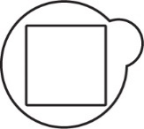 | Square Used for Area of Pain / Concern:  ☐ Place square over focal area of pain / concern if patient can point  with one finger.  ☐ Areas of concern include anything that can image and may result in  a recall. Checked boxes below indicate what this facility will mark:  ☐ Sebaceous Cysts  ☐ Rash  ☐ Bug Bites  ☐ Other Areas of Concern deemed appropriate by the interpreting  radiologist which include: Click or tap here to enter text.
Warnings and Precautions: | - Single Patient Use Only; Do Not Reuse 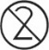  - External Use Only; Do Not Ingest or Swallow  - Do Not Place on Compromised Skin  - Remove After Use  - Not Made with Natural Rubber Latex  - Lead-Free  - Non-Sterile 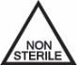
Vendor Information | Manufactured by Beekley Corporation  One Prestige Lane, Bristol, CT 06010  800.233.5539  BEEKLEY, BEEKLEY MEDICAL, BEEKLEY SKIN MARKING SYSTEM, SPOT, and WHEN YOUR DIAGNOSIS  MUST BE RIGHT are Reg. U.S. Pat. & Tm. Off. BEEKLEY and SPOT are Registered Community Trademarks. BEEKLEY is a registered trademark in Canada. All other trademarks are the property of their  respective owners.  © 2021 Beekley Corporation. All Rights Reserved.

AUTHORIZED BY: Click or tap here to enter text. DATE: Click or tap here to enter text.

REV: BSMS_FM_0421

